Problem 04.
Investigating antenna organization and energy trapping efficiency.

Given:
A linear chain of N antenna pigments (blue) equidistant from each other both spatially and energetically (shown is the case of downhill transfer arrangements):
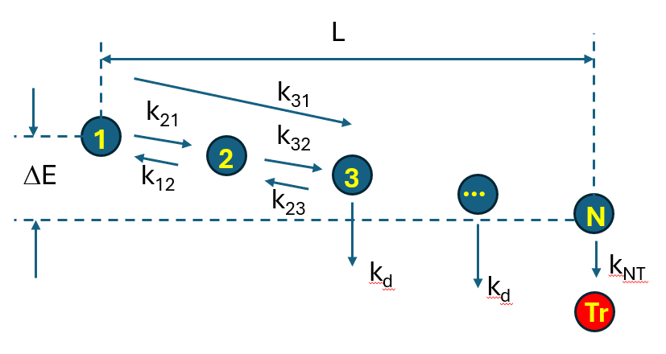
1. Energy transfer rates between all pairs (i j ) of pigments, kij, follow the Förster equation, i.e.:
You can approximate the κ²=1 in this equation. The Förster radius depends on the energy shift between the donor and the acceptor; the respective values have been calculated in the previous homework. To simplify the problem, I have approximated the previous homework data using the 7th-order polynomial function of the energy shift between donor and acceptor ΔE measured in units of kT (kT=207 cm⁻¹ for T=298K):
Here, the function R₀ is only defined for downhill energy transfer (-10 < ΔE ≤ 0) and the respective coefficients are, in descending order (c_{m}, c_{m-1},…,c₀ ):
coeffs = [2.72287012e-04, 8.93595000e-03, 1.07678267e-01, 5.43035167e-01,
6.77673247e-01, -2.52047318e+00, -4.37266412e+00, 5.41844510e+01]

The uphill energy transfer is found as a complimentary for downhill transfer rate using the Boltzmann factor exp(-ΔE) (note that 1/kT is dropped as ΔE is measured in units of kT). We have provided the Python class Forster for your convenience to calculate the transfer times τ_{ij} as a function of distance R_{ij} and ΔE_{ij}; note that k_{ij} = 1/τ_{ij}. It is important to use the Boltzmann factor since this ensures correct thermodynamics of the process. Here is the Forster radius as a function of shift in nm and in kT units (Forster.plot() function):
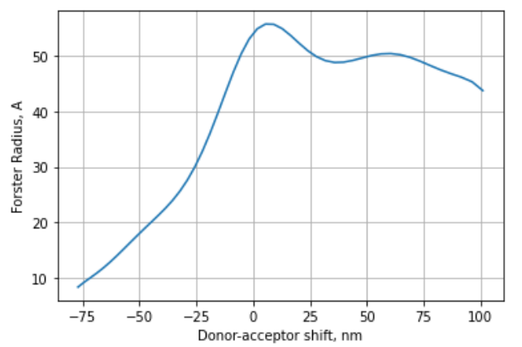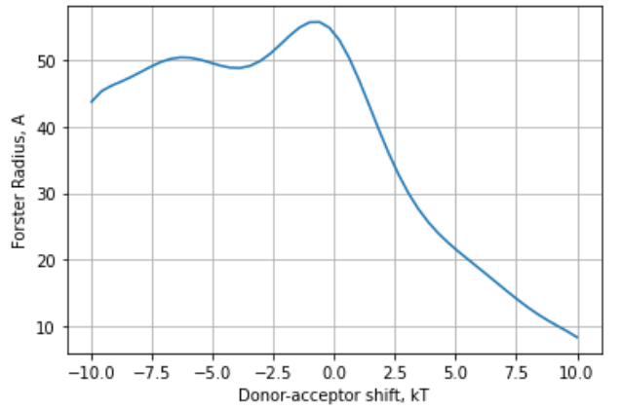

2. In addition, each antenna pigment decays into the ground state with a time constant τ_{d} =1000 ps (k_{d}=1/τ_{d}).

3. The last pigment initiates irreversible charge transfer (excitation trap) with time constant τ_{NT} = 0.05 ps, k_{NT} = 1/τ_{NT}.

TASK1: Write the simulation program
- The input parameters that could be changed to investigate different models are:
- N, the number of antenna pigments
- L, the length of the linear chain in space
- deltaE, the energy difference between the last and the first antenna pigments (negative for downhill energy transfer)
- τ_{d}, τ_{NT}
- Write a program that calculates the population dynamics of this system (Lecture 8):
- Generate the K-matrix for this system. Since there are N antenna pigments and a trap, the matrix should have size N+1, with the last entry corresponding to the irreversible trap. If you use Python, stick to numpy array as the matrix class has been deprecated in newer versions. You will have to set both forward and backward transfers in the matrix for all pairs, i.e., the NxN sub-matrix will have all elements defined (not zero). For the transfer to trap there will be just one forward transfer rate, K[N][N-1] = 1/τ_{NT} . Note that numbering in Python starts from 0, so the last element (trap) index will be N, and the last pigment in the chain is N-1.
- Using the K-matrix, generate the rate matrix R (see lecture 8)
- Define the initial population vector n, which must have N+1 elements, where the last element n[N] corresponds to the population of the trap. Set the initial population of all antenna pigments to 1/N and the trap population to 0. This assumes that all antenna pigments are excited uniformly.
- Construct the loop that calculates n(t) recursively using some short time increment dt, where dt has to be significantly shorter than any other transfer time in the system. As the criterion to stop calculation, you can calculate the antenna population (i.e., the sum of all elements in n except the last), once it is small (say <1e-4), most of the excitations have been trapped, and no big changes are expected. Or you can run the loop for a long enough time that the population on trap does not change. Store vectors n in some list for future plotting. You may not want to store every recursive step, as the list will be too large.
- Plot populations of some pigments and trap as a function of time. The trap population should asymptotically reach some maximum value, which will correspond to the quantum efficiency of excitation trapping.
- In the appendix, we provide some results of the model, which you can use to test if your program works correctly

TASK2: Investigate energy trapping in the following arrangements of pigments

Use the distance reference R0=56 (Angstroms).
Analyze the quantum efficiency of trapping using the following parameters for a small antenna:
- L = 2*R0; N=5; ΔE = -2.
- L = 2*R0, N=5, ΔE = +2
Now lets increase the spatial size of the chain:
- L = 6*R0; N = 21; ΔE = -2.
- L = 6*R0; N = 21; ΔE = +2.
- L = 6*R0; N = 21; ΔE = -4.
- L = 6*R0; N = 21; ΔE = +4.
Add more pigments per the same length:
- L = 6*R0; N = 61; ΔE = -2.
- L = 6*R0; N = 61; ΔE = +2.
- L = 6*R0; N = 61; ΔE = -4.
- L = 6*R0; N = 61; ΔE = +4.

Turn in:
- Plot the dynamics of antenna excitation (cumulative population on all antenna pigments) and charge-separated state (trap) formation as a function of time for all arrangements.
- Find quantum efficiency of charge separation in these scenarios (i.e., averaged probability of charge separation per absorbed photon).
- How long does it take for charge separated population to form? (estimate, it is not a simple exponential)
- Discuss the data: how does trapping efficiency depend on the uphill or downhill (sink) arrangements, pigment separation, and the number of pigments? Recall that the photosystem I antenna has 96 pigments arranged ‘randomly’, and trapping time is between 20 and 30 ps.
- Attach your program source
Note: Using that code, one can model real systems like photosystem I, by using 3D-coordinate system to specify Chl positions (from PDB structure), directions of transition dipole moments (for κ), and the transition energies.

Appendix: class Forster
You can use this Python class to calculate transfer times between two pigments, given the spatial distance between them and the energy shift between acceptor and donor (downhill means dE<0)

########################## FORSTER CLASS ######################################
# Calculates Chl a to Chl a transfer rate using the distance between donor
# and acceptor in Ansgstroms, and polynomial fit to R0 vs energy shift
# between donor and acceptor in kT units at room temperature calculated
# from absorbance and fluorescence spectra in previous homework.
# USAGE:
# F = Forster() - defines class and initializes it
# tau = F.get_tau(dist,shift) - returns donor-acceptor energy transfer time in picoseconds
# distance dist in A, and energy difference shift
# shift is in kT units and is negative for downhill transfer, must be between -10 and +10.
class Forster():
def __init__(self): # initialize class
#define polynomial coefficients for forward transfer (for negative shift only)
# valid for dowhill shifts = 0...-10 only!
self.coeffs = [2.72287012e-04, 8.93595000e-03, 1.07678267e-01, 5.43035167e-01,
6.77673247e-01, -2.52047318e+00, -4.37266412e+00, 5.41844510e+01]
self.tau = 10000 # radiative lifetime of Chl a in ps (=10 ns)
return

#get donor-->acceptor transfer time, distance between pigments in A, energy shift in kT
# shift MUST be between -10 and +10, the range were R0 was fitted with polynomial
def get_tau(self,dist,shift):
R0 = np.polyval(self.coeffs,-abs(shift)) # Forster R for downhill transfer (shift <=0)
t = self.tau * ( abs(dist) / R0)**6 # forward transfer time
if shift>0: t = t * math.exp(shift) # mult by Boltzmann if uphill transfer
return t

# helper functrion, plots R0 graph in kT ('kT') or nanometers (units='nm')
def plot(self,units = 'kT'):
xx = np.linspace(-10,10,50)
yy = []
for x in xx:
R0 = np.polyval(self.coeffs,-abs(x))
if x>0: R0=R0 * math.exp(-x/6)
yy.append(R0)
if units == 'nm': xx = (1e7/(1e7/650 + xx*207)) - 650
else: units = 'kT'
plt.plot(xx,yy); plt.grid();
plt.xlabel('Donor-acceptor shift, ' + units);
plt.ylabel('Forster Radius, A')
return
######################## end of Forster class #################################

Appendix: test results
You can test if your program works correctly using the following output of the working program.
Here, we define the following parameters of the problem:

R0 = 56. # Forster radius in Angstroms at optimal shift, use as a scaler
L = 2.*R0 # distance between the first and last pigment in a line
N = 7 # N antenna pigments, will add trap:
deltaE = -2 # separation between the first and last antenna pigment in kT, <0 is downhill
dt = 0.002 # time step for the recursive loop

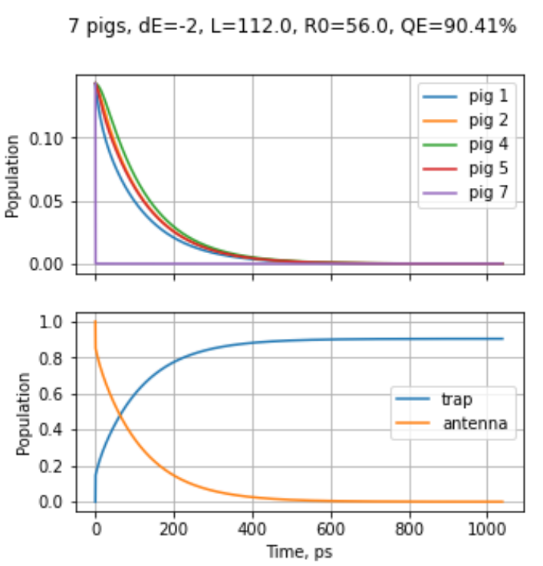
The graph above shows n as a function of time. The antenna population is the total population of all antenna pigments (i.e., the sum of N-1 elements of n). The trap population is the last element in n as a function of time. Some other parameters printed by the program:

Forward transfer time = 14.7238
Backward transfer time = 20.5486
Distance bewtween pigs = 18.67 = 0.333 x R0
Transfer from 7 to trap = 0.0100
Quantum yield: 0.9041051090365632
Antenna pop at max time: 9.999975624312878e-05

Here, the Forward transfer time is the energy transfer time between pigment i and i+1, forward along the chain (τ_{i+1,i}), the Backward transfer is the transfer backward along the chain (τ_{i,i+1}), etc. Quantum yield is the maximum population of the trap (90.4%) at the end of the simulation. The Antenna population has to be very small at the end of the simulation (i.e., all excitations are trapped).

